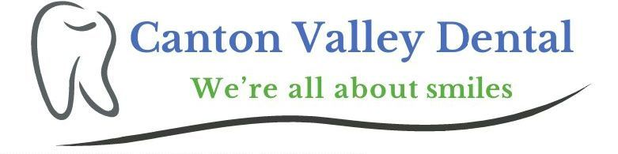

Welcome to the Canton Valley Dental Membership Plan. If you currently do not have dental insurance coverage, our plan offers many benefits that allow you to receive optimal dental care while saving money. You save on everything from cleanings and fillings to cosmetic procedures and crowns. We have taken steps to enable you and your family to get the care that you need at an affordable cost. We hope that you utilize this plan to improve and maintain oral health for yourself and your family for years to come.

Annual Enrollment fees
Adult plan is $500/year (Savings of $155, normally $655)
Child plan is $400/year (Savings of $305, normally $705)
Patients who participate in our Membership Savings Plan experience the following benefits:
• Two cleanings
• Two periodic exams
• One set of routine x-rays
• One emergency exam and x-ray
• Two topical fluoride applications for children up to age 16

Perio Membership Plan Annual Enrollment fees
$900 per Member (Savings of $335, normally $1235)
Patients who participate in our Membership Savings Plan experience the following benefits:
• Four Perio Maintenance cleanings
• Two periodic exams
• One set of routine x-rays
• One emergency exam and x-ray

No waiting periods-immediate treatment, No deductibles, No coverage limitations, No Exclusions
5% off each additional family member in the same household

***All other dental treatment will be offered at a 15% discount if paid in full on the date of service***
(Fillings, extractions, root canals, crowns, bridges, dentures, partials, implants, etc.)

Coverage begins upon receipt of completed and signed contract, and when payment is received in full. Membership extends for one year for each individual patient from the date of receipt. Membership fee is non-refundable and non-transferable.
I have read, understand and agree to all of the above. I have been given the opportunity to ask questions.

___________________________________ _____________________________________________ ____________
Printed Name Signature Date

